Statistical Science Workshop 6-7 March 2025 University of Waikato – Tauranga

10-11 March University of Auckland – Leigh Marine Lab

Instructor: David Schneider. Memorial University, St. John’s, Canada

*..statistics must be relevant to making inferences in science and technology.*

*The subject should be renamed statistical science and be focused on the experimental cycle, design-execute-analyse-predict. John Nelder 1999*

What is statistical science?

Statistical science is defined as the application of inferential statistics to the analysis and interpretation of scientific measurements.

Statistical science is not a collection of statistical methods.

Statistical science is not the search for the “best” statistical test.

Statistical science is not the pursuit of p < 0.05

Statistical science is founded on writing a model appropriate to the data generated by a research question.

It uses likelihood ratios to compare statistical models (Fisher 1925).

It uses likelihood ratios to replace the erroneous use of p-values as evidence (Goodman 1993).

It requires a model checking loop (Nelder 1999).

It entails distinguishing three modes of inference, all based on likelihood ratios.

Frequentist Inference from sample to a population via the law of large numbers (Laplace)

Priorist (“Bayesian”) Inference from prior to posterior probability (Laplace 1812, Keynes 1921).

Evidentialist Inference from data to model parameters (Royall 1997, Nelder 1999).

In this workshop you will learn to

Translate a research question into a statistical model

Execute the model and apply the model-checking loop

Calculate a measure of evidence for the research hypothesis (the likelihood ratio)

Calculate a measure of uncertainty on the likelihood ratio (p-value / confidence limit))

Report effect sizes with a measure of uncertainty

Interpret parameter estimates in light of the research question

Goal of the third session Writing the statistical model for the Generalized Linear Model GzLM

Goal of the fourth session Executing a GzLM in a statistical package

Using the model checking loop

Interpreting computer output

Interpreting the parameter estimates

Statistical Science Workshop Session 3 – Writing the model for a Generalized Linear Model.

Definitions.

Quantities -- Definition

A well-defined quantity has 5 parts:

a name;

a procedural statement that prescribes the conditions for measurement, or calculations from measurements;

a set of scaled numbers generated by the procedural statement;

units on one of several types of measurement scale;

a symbol that stands for the set of scaled numbers.

The Generalized Linear Model uses parameters $β_{x}$ to relate one or more response variables *Y*

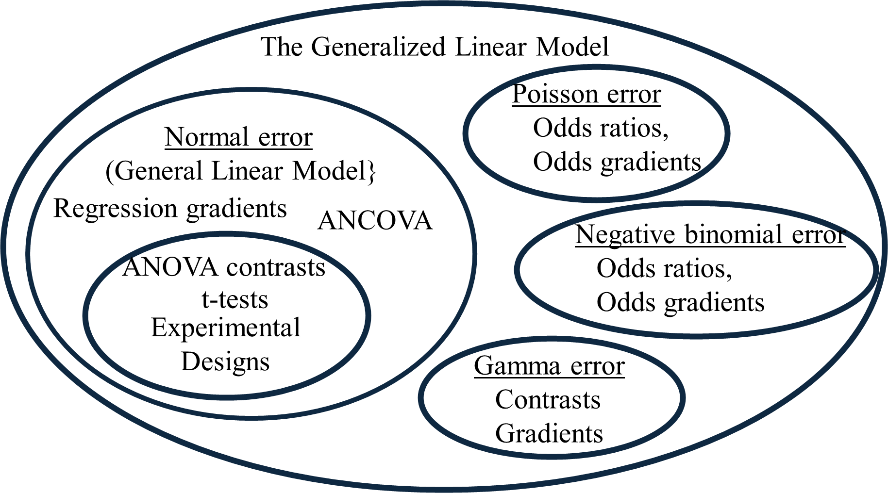 to one or more explanatory variables XA, XB, *etc*

*Y* ~ Error model (*e.g.* Gamma error)

$η= β_{o}+β_{XA}{XA}_{1}+β_{XB}{XB}_{1}$

*Y* = e *η*  (log link for Gamma error)

Regression: $β_{XA}$ = Gradient (change in Y/change in XA)

ANOVA: $β_{XA}$ = Contrasts: $β_{o}-β_{XA_1}$, $β_{o}-β_{XA_2}$ , *etc*

Statistical Science Workshop Session 3 – Writing the model for a Generalized Linear Model

Statistical Science Workshop Session 3 – Writing the statistical model from GzLM

Second example

Does inversion heterozygosity (HZYG) change with elevation above sea level (*Hsl*) in *Drosophila* *persimilis*). Data are from Dobzhansky (1948) as reported in Brussard (1984).

|  |  |
| --- | --- |
| Source | df |
|  |  |
|  | 5 |
|  |  |

One measurement of HZYG at each of 7 different elevations.

Response variable with symbol ______________________ ______

Explanatory variable with symbol ___________________ ______

The response variable is bounded at zero and one.

The normal distribution extends beyond these bounds.

The normal distribution performs poorly for parameter estimates near the boundary;

The 20th century solution is the arcsin transform.

This transforms the response variable to value beyond the bounds.

This addressws the problem of non normal error distribution.

It results in uninterpretable estimates of parameters.

The 21st century solution is a GzLM with betabinomial error.

This error distribution talks the logit link.

Write the model in three part form.

Distribution ________________________________________

Structural model ____________________________________

df ________________________________________

Link function ______________________________________

Emilie A. Geissinger, Celyn L. L. Khoo, Isabella C. Richmond, Sally J. M. Faulkner, David C. Schneider 2022

A case for beta regression in the natural sciences.

https://esajournals.onlinelibrary.wiley.com/doi/10.1002/ecs2.3940

Statistical Science Workshop Session 3 – Writing the statistical model.

Fourth example (ANCOVA)

Does change in inversion heterozygosity (HZYG) with elevation above sea level (Hsl) in *Drosophila* *pseudoobscura*) differ from that of *D. persimilis* at the same locations?

Data are from Dobzhansky (1948) as reported in Brussard (1984).

|  |  |
| --- | --- |
| Source | df |
|  |  |
|  |  |
|  |  |
|  | 10 |
|  |  |

One measurement of HZYG at each of 7 different elevations in two species.

Response variable with symbol ____________________________ _______

Explanatory variable V1 with symbol _____________________ _______

Second explanatory variable V2 with symbol ________________ _______

Interactive effect (compares slopes) V1 x V2 _____________ _______

Model ____________________________________________________

df ____________________________________________________

Statistical Science Workshop Session 1 – Writing the statistical model.

Review of Session 3

The learning goal was to write a generalized linear model to address a research question.

This replaces the use of transformations, which often result in uninterpretable parameters

Once learned, we can write a model for which we do not know the name.

For example, students can execute a beta-binomial analysis, even though they do not know the name of the test.

Along the way, we learned several important concepts:

Explanatory vs response variables

Parameters relate response to explanatory variables.

Categorical (ANOVA) vs ratio scale (regression) variables.

Use of contrasts to compare means of a categorical variable.

Partitioning the degrees of freedom in an ANOVA table

We set up the model for four examples – two regressions, an ANOVA, and an ANCOVA.

In Session 3 we will learn to use a generic recipe for statistical analysis, based on writing the model.

The recipe will be demonstrated for Gamma error, where the normal error produced unacceptably heterogeneous residuals.

As time permits, another example will be demonstrated while you carry it out in the statistical package.